The Vault Keeper: A Private, Self-Hosted Alterative to Public Cloud Storage

By: Taha Anwar, Tomas Chaparro, John-Paul Osele, and Cole Roberts

Table of Contents

Project Proposal 3
Project Abstract 3
High Level Requirement 3
Conceptual Design 3
Proof of Concept 4
Background 4
Required Resources 4
Project Design 4
Vision 4
Persona #1 – Elliot Alderson, A Junior Software Developer 5
Persona #2 – Sarah Williams, A Graduate in Accounting & Finance 5
Persona #3 – Max Caulfield, A High School Senior & Multimedia Art Student 6
Persona #4 – Norman Jayden, An Independent Legal Consultant & Compliance Auditor 7
Persona #5 – Lee Everett, A Researcher in Anthropology 8
Class Diagram 9
Sequence Diagram 10
Automated Test Results 11
Project Progress 12
Week 1 Progress 12
Week 2 Progress 14
Week 3 Progress 14
Week 4 Progress 14

Project Proposal

Project Abstract
The Vault Keeper is a self-hosted cloud storage platform designed to provide data independence by eliminating 3rd party data mining and providing free customization. While products like Google Drive and Dropbox already exist, users don’t have full freedom to customize and use these services. With “The Vault Keeper,” I propose a lightweight and open-source solution that allows users to customize and manage their own data for free. The software’s main use is to provide an environment that allows users to upload, store, and manage their files on a private Linux server. The file management will be seamless and provide log file data to track changes to files. This software is intended for people who care more deeply about their digital privacy, developers looking for secure and internal file sharing, and users looking for completely free and customizable alternatives to existing products. This project demonstrates good security practices and offers users a secure environment for internal data handling.

High Level Requirement
The Vault Keeper allows users to securely access a private storage environment to upload, manage, and download personal files through an intuitive web interface. The system ensures data privacy by isolating storage on an Ubuntu Linux server and maintains transparency by automatically logging all file interactions in an activity log.

Conceptual Design
The Vault Keeper is built on a high-performance, client-server architecture designed for privacy and environmental isolation. The system is split into a zero-knowledge frontend and a high-concurrency backend to ensure that sensitive data is encrypted before it ever leaves the user's local environment.

The system uses a model where the storage backend resides on a private Ubuntu Linux server, isolated from the user's primary hardware to protect against local failures or malware.
- Frontend: All encryption happens client-side. The server acts as a vault that stores encrypted files without ever possessing the keys to read them.
- Backend: The backend manages the intake of these encrypted files by organizing the metadata in the database and handles the activity log auditing.

With the decision to prioritize performance and modern web standards, the following tools have been selected:

Category | Tool | Reasoning
Frontend | React (Vite) + Tailwind | Enables fast development, easy Dark Mode implementation, and PWA support.
Backend | FastAPI (Python) | Selected over Flask for its high performance with file streams and greater asynchronous support.
Database | SQLite | A simple, portable, and file-based database that requires no extra server overhead.
Storage | Local Linux Directory | The most direct way to handle large file volumes on a self-hosted Ubuntu server.
Auth/Security | Web Crypto API | Implements client-side encryption to ensure the server remains zero-knowledge.

Proof of Concept
Link to repository: https://github.com/cis3296s26/The-Vault-Keeper
Link to Live Beta: https://the-vault-keeper.vercel.app/
This proof of concept was done on a Windows environment to check framework compatibility. Currently, a live beta is deployed using Vercel to demonstrate the React/FastAPI integration. In the final project, the Ubuntu Server will serve as a separate, standalone deployment environment. With this key element, the application logic and data storage are isolated from the user’s machine, providing environmental isolation. A README.md is added with System Specifications & Compatibility as well as instructions on how to run.

Background
The Vault Keeper addresses concerns with cloud platforms and data ownership with similar platforms like Google Drive lacking transparency. While there are existing alternatives, they are often too complex for a single user’s needs. The Vault Keeper is a project designed to be simpler, lightweight version of these existing services. By building this from scratch with free tools, I am proposing a Client-Server architecture where the Ubuntu Linux Server acts as a separate deployment environment from the user’s local machine. Using FastAPI to manage this architecture allows for efficient data isolation, protecting files from hardware failures or malware. This provides users with a personal and transparent way to manage their data across a network rather than storing it on a local hard drive.

Required Resources
- Software & Frameworks: Python 3.10+ with FastAPI for the backend and React (Vite) for the frontend.
- Infrastructure: Ubuntu Server 22.04 LTS hosted via VirtualBox for environmental isolation.
- Data & Security: SQLite for metadata/logs and Web Crypto API for client-side encryption.
- Hardware & Tools: GitHub for version control and a PC/Laptop with at least 8GB RAM to handle the development tools and VM simultaneously.

Project Design

Vision
For everyday people who care about what happens with their personal data and want to take control of how that data is managed. The ‘Vault Keeper’ provides a customizable application that allows users to track and manage personal files on a free and private Linux server. Unlike traditional file managers that store these files for the user, ‘The Vault Keeper’ is solely managed by the user. Our product uses this advantage to provide security to the user, as they know that they are in control and third parties won’t have access to their data.

Persona #1 – Elliot Alderson, A Junior Software Developer
Name: Elliot Alderson
Age: 26
Occupation: Junior Software Developer at a mid-sized fintech company
Educational background:
- Bachelor’s degree in Computer Science
- Completed several online certifications in cybersecurity and Linux systems administration
Technology experience:
- Highly proficient
- Their daily driver is Linux (Arch)
- Comfortable with the command line, Git, and self-hosting services on a home server
- Actively avoids cloud services that monetize user data
Demographics:
- Technically motivated hobbyist who runs a home lab
- Part of several open-source and privacy-focused online communities (e.g., r/selfhosted, r/privacy)
- No family dependents, so the storage is purely personal and professional
Why would they use the vault keeper:
- Store personal projects, credentials, and sensitive documents without trusting a third party like Google or Dropbox
- Wants to see exactly what the software does; appreciates that it’s open-source and lightweight
- Values the activity log feature to audit exactly who accessed or modified what files
- Would likely contribute feedback or even pull requests to the project
Potential difficulties:
- May want more advanced features (e.g., AI integration to search files just from a natural language description) that aren’t available in early versions
- He could also become frustrated if the documentation is sloppy or imprecise

Persona #2 – Sarah Williams, A Graduate in Accounting & Finance
Name: Sarah Williams
Age: 23
Occupation: None; working on finding a job in accounting
Educational background:
- Bachelor’s degree in Accounting & Finance
Technology experience:
- Very familiar with excel and has dabbled in the language R in one of her Economics classes
- Has no difficulties using her phone or laptop, but is slow to learn new software
- Likes it when the apps she downloads are easy to use and provide user guides
Demographics:
- Just graduated and has gone back home to live with her parents until she finds a job
- Looking to live and work in a big city on the East Coast (she’s been on the West Coast her whole life)
- Lives on a tight budget, even at home with her parents, because she knows her student loans are going to eat a lot of her salary
Why would they use the vault keeper:
- Sarah likes to stay organized and wants a way to store files that she can customize
- She knows that she’ll be dealing with internal company files in the future, so she wants to practice keeping personal files safe at home
- She is currently on a budget and would like the fact that Vault Keeper is free to use
- She has seen many articles online about how companies steal data. She doesn’t understand how it happens and would like a way to avoid it
Potential difficulties:
- Sarah is not very technical, so she might have trouble setting up the app
- If the app does not have a tutorial or guide, she won’t touch it
- If the app is not easy to use and intuitive, she’ll move to a different app

Persona #3 – Max Caulfield, A High School Senior & Multimedia Art Student
Name: Max Caulfield
Age: 18
Occupation: High School Senior and Multimedia Art Student
Educational background:
- Completing a high school diploma with a focus on Fine Arts and Creative Writing
Technology experience:
- Moderately experienced with apps, but not experienced with more technical uses of technology
- An expert in Procreate, Canva, and digital journaling apps
- Uses her phone and tablet a lot to capture important ideas, sketches, and diary thoughts
Demographics:
- Lives with their family with a shared family computer
- Sells customs stickers and makes art prints for the school newspaper
- Values her digital space and treats it as an extension of her personal expression, like a nichely decorated bedroom
Why would they use the vault keeper:
- Max likes to switch to Dark Mode sometimes and the ability to organize her files freely makes the Vault feel like her own curated gallery
- She uses the drive to store scanned diary pages and art that she wants to keep private
- She likes the idea of password protected files to lock away her ideas, making her feel secure that her ideas and information are written down safely, available to open at any time
- She prefers self-hosted tools because it feels more unique compared to generic public cloud services, bringing out her artistic vibe
Potential difficulties:
- She might find the idea of a Linux server setup intimidating since it’s not a standard one-click install
- If there’s an error in the Python backend, she won’t be able to fix it without extremely simple, non-technical instructions

Persona #4 – Norman Jayden, An Independent Legal Consultant & Compliance Auditor
Name: Norman Jayden
Age: 43
Occupation: Independent Legal Consultant and Compliance Auditor
Educational background:
- Political Science BA & Juris Doctor (JD)
Technology experience:
- Moderate
- Proficient in legal research databases and digital documentation
- Uses technology as a tool for organization but is skeptical of Big Tech data-sharing policies and cloud-based Terms of Service that might compromise attorney-client information
Demographics:
- Works solo out of a home office
- Handles sensitive corporate governance documents and private litigation files for small firms
- Prefers personal control over his library and records rather than relying on subscription-based services.
Why would they use the vault keeper:
- To ensure third-party data miners cannot scan private legal contracts
- Likes the use of activity logs to prove when documents were changed
- Likes the extra layer of protection that locally hosted services provide
- Since he is very meticulous, he enjoys keeping files in a place he physically controls/customizes
Potential difficulties:
- Initially he might find managing a Linux server distracting from his legal work
- Worries that a mistake on a self-hosted platform could lead to data loss or security issues

Persona #5 – Lee Everett, A Researcher in Anthropology
Name: Lee Everett
Age: 37
Occupation: Researcher in Anthropology
Educational background:
- BA in Anthropology & Ph.D. in Anthropology
Technology experience:
- Moderate
- Expert in qualitative data software and handling notes digitally
- Often works in regions with unreliable internet, so he distrusts public clouds for storing sensitive interviews that could put people at risk
Demographics:
- Travels frequently for research
- Values safe tools that aren’t hidden behind a paywall for full access
Why would they use the vault keeper:
- Needs to apply ethical research practices and anonymity of participant data
- Finds the platform useful for publishing unedited findings before public publishing
- Prefers a simple and customizable layout
Potential difficulties:
- Might have trouble accessing the tools needed for the platform while in the field, so notes will need to be passed onto the server afterward
- Needs assistance/tutorials initially, since he has been using the same software for years

Class Diagram

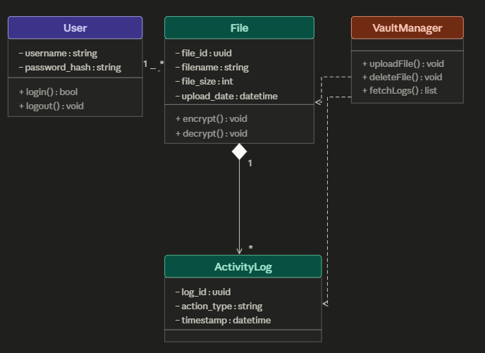

Explanation
This class diagram shows the four main parts of the app and how they connect.
- User: Stores the username + password and handles logging in and out.
- File: Represents anything that’s uploaded and tracks the name, date, size, and knows how to encrypt/decrypt itself.
- Activity Log: Keeps a record of changes to a file. The filled diamond connection signifies the fact that a log entry cannot exist without its file, so if the file is gone, so is its history.
- Vault Manager: The coordinator which doesn’t store anything on its own, but instead calls example commands such as: uploadFile(), deleteFile(), and fetchLogs().

Sequence Diagram

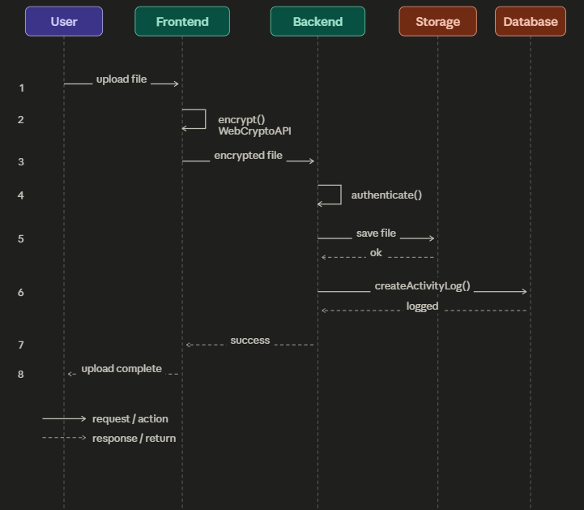

Explanation
This sequence diagram shows the main sequence of events between the different parts of the application.
- The User clicks upload and the Frontend receives the file
- The Frontend encrypts it using the WebCryptoAPI
- The encrypted file goes to the Backend
- The Backend checks the is authenticated
- The files gets saved to Storage
- The Backend logs the action in the Database and the confirmation of success goes back to the User

Automated Test Results

**No Current Test Results from Existing Code**

Currently, automated unit test results aren’t available because the project is in an active rapid prototyping phase. To meet early deadlines, our team prioritized the development of a live beta to validate the integration between the FastAPI backend and React frontend for The Vault Keeper. Manual testing was performed to ensure the beta is stable and functional and automated testing is scheduled for implementation in the next sprint (Week 2).

Project Progress

Week 1 Progress
Scrum Master: Taha Anwar & John-Paul Osele

Sprint Goal: Finalize the core system architecture, start creating the database backend, and start the initial frontend prototype for beta testing.

Backlog Features
- Web Interface: Initial React frontend and Figma prototype for file management
- Database & Storage: SQLite setup and FastAPI backend for handling file uploads
- Security Tools: Client-side encryption research and a random password generator
- System Documentation: Finalizing the Project Proposal and UML design diagrams
- Project Documentation: Renewed proposal and high-fidelity UML diagrams.
- Security & Authentication: Random password generation and initial authentication logic.
- Testing: Comprehensive beta testing phase for the storage environment.

Tasks in Sprint | Task Status at end of Sprint | Assigned To
#34 – Set up database for  the backend | Completed | Cole Roberts
#23 – Start making front  end | Completed | Cole Roberts
#33 – Create Figma prototype  and start on frontend | Completed | Cole Roberts
#25 – Make progress on the backend | Completed | Taha Anwar
#21 – Fix the release issue | Completed | Cole Roberts
#24 – Research optimal tools for UI/backend | Completed | Taha Anwar / John-Paul Osele
#14 – Random Password Generator | Completed | Tomas Chaparro
#32 – Final Tech Stack | In-Progress | Taha Anwar / John-Paul Osele
#16 – Password Protected Files | In-Progress | Tomas Chaparro
#52 – Create Documentation File | Completed | Taha Anwar
#49 – Renew Project Proposal | Completed | Taha Anwar
#50 – Add first UMLs for class / sequence | Completed | Taha Anwar
#51 – Complete Beta Testing + Documentation | Completed | Taha Anwar
#14 – Random Password Generator | Completed | Tomas Chaparro
#34 – Set up database for the backend | Completed | Cole Roberts
#33 – Create Figma prototype/frontend | Completed | Cole Roberts
#15 – File Filtering and Sorting | In-Progress | Tomas Chaparro
#31 – Add authentication | Not Started | Team

Estimated Velocity  (At beginning of Sprint) | 27
Calculated Velocity  (At end of Sprint) | 19

Week 2 Progress

Scrum Master: Cole Roberts

Sprint Goal: Improve upon the backend and implement the frontend based on the existing backend. Also, documenting the architecture and setting up for the implementation of the final features list.

Backlog Features
- UI/UX Finalization: Completing the UI/UX (app experience) visually for the frontend
- Linux Research: Researching server-side storage of files, how it works, and how to integrate Linux
- Advanced File Handling: The implementation of multiple-file uploads and password protected files for selected files
- System Feedback: Adding confirmation modals for user interaction and intuitiveness

Tasks in Sprint | Task Status at end of Sprint | Assigned To | Size
#45 – Add confirmation modals (V2) | In Progress | Cole Roberts | 3
#54 – Finalize UI/UX Design | Complete | Cole Roberts | 8
#42 – Make mobile friendly | In Progress | Cole Roberts | 5
#42 – Change website title and favicon | In Progress | Cole Roberts | 1
#55 – Complete Week 2 Scrum Review  Documentation | Complete | Taha Anwar | 3
#30 – Password Protected Files | In Progress | Tomas Chaparro | 5
#22 – Research Linux utilization & storage | In Progress | Taha Anwar & Tomas Chaparro | 5
#43 – Add multi-file upload | In Progress | Taha Anwar | 5
#59 – Dockerize Project | Complete | John-Paul Osele | 8
#57 – File Filtering and Sorting | Complete | Tomas Chaparro | 5

Estimated Velocity  (At beginning of Sprint) | 48
Calculated Velocity  (At end of Sprint) | 24

Week 3 Progress

**Upcoming Sprint; Not Yet Started**

Week 4 Progress

**Upcoming Sprint; Not Yet Started**

